Housing Prices Prediction – Code Explanation

1. Project Overview
This project predicts house prices using machine learning. The dataset comes from the Kaggle 'Housing Prices Competition for Kaggle Learn Users'. The code loads the training and test datasets, preprocesses the data, trains a machine learning model (XGBoost), evaluates the model, and finally creates a submission file for Kaggle.

Competition Screenshot
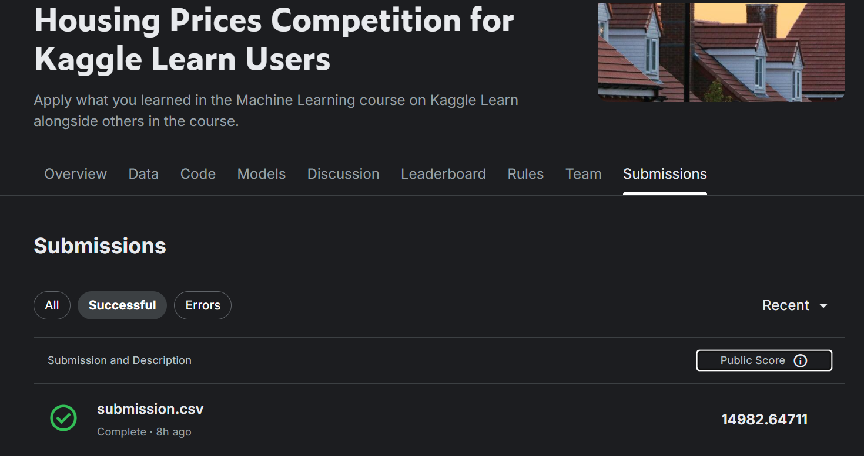
The above screenshot shows the Kaggle competition submission page with a successful submission and a public score.

2. Importing Libraries
The first step is importing all required Python libraries:
- pandas and numpy for data handling.
- xgboost for the machine learning model.
- sklearn modules for preprocessing, splitting data, and evaluation.

3. Loading the Dataset
The training dataset (train.csv) and testing dataset (test.csv) are loaded using pandas. The training dataset contains the target variable 'SalePrice', while the test dataset contains the features used for prediction.

4. Log Transformation of Target Variable
The SalePrice column is transformed using log1p. This transformation helps stabilize variance and makes the model perform better when house prices vary widely.

5. Feature Selection
The code defines two types of features:
1. Numerical features such as LotArea, YearBuilt, and GrLivArea.
2. Categorical features such as Neighborhood, KitchenQual, and HouseStyle.
These features are used as inputs to train the machine learning model.

6. Data Preprocessing
Before training the model, missing values and categorical data must be handled:
- Numerical features use SimpleImputer with the median strategy.
- Categorical features use the most frequent value for missing data.
- OneHotEncoder converts categorical values into numeric vectors.
A ColumnTransformer combines both numerical and categorical preprocessing steps.

7. Model Creation (XGBoost)
The code uses the XGBRegressor model. Important parameters include:
- n_estimators: number of trees used in the model.
- learning_rate: controls how quickly the model learns.
- max_depth: maximum depth of each decision tree.
- subsample and colsample_bytree: improve generalization and reduce overfitting.

8. Training Pipeline
A machine learning pipeline is created. The pipeline ensures that preprocessing and model training happen together in a single workflow.

9. Model Training and Validation
The dataset is split into training and validation sets using train_test_split. The model is trained on the training data and predictions are made on the validation data. Model performance is evaluated using an error metric.

10. Training on Full Dataset
After validating the model, it is trained again using the full training dataset so that it can learn from all available data.

11. Making Predictions
The trained model predicts house prices for the test dataset. Since the target variable was log transformed earlier, the predictions are converted back to normal values using the exponential function.

12. Creating Submission File
Finally, the predicted prices are saved into a submission.csv file with two columns:
- Id
- SalePrice
This file can be uploaded to Kaggle to receive a score on the leaderboard.

